**Chapter 9 Hands-On Test**

Web Development Technologies –

**71%**



❏ Develop a **page** to sell a widget(s) or product(s) of your choice.

❏ <header> includes logo and navbar

❏ Include the company name, with image logo, and make this image a link to the home page **- 5pts**

❏ Include a single-tiered navbar with 5 links (href=”#”) using appropriate semantic tags **- 5pts**

❏ <section> includes a Call to Action

❏ Include a heading, a smaller heading, and a link styled as a button to “BUY NOW” **- 5pts – 3 pts**

❏ Include a Featured Image to the right of the text and button **- 5pts**

❏ <main> includes two sections of content:

❏ Top section with 3 div’s of content

❏ Each div has [rounded image](https://www.w3schools.com/howto/howto_css_rounded_images.asp), a heading, a short description **5pts**

❏ Bottom section of with a heading and 4 div’s of content

❏ Each div has a square images, a heading, and paragraph **- 5pts**

❏ <footer> includes copyright line. Such as "© 2021 Company Name" Must use copyright HTML entity**- 5pts**

***Note** Footer not shown in Mock Up***

***(Desktop View)***

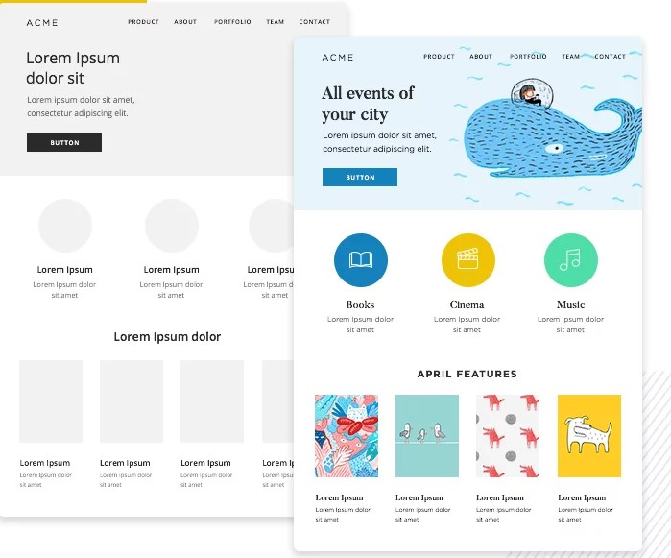

❏ Use **CSS** to responsively implement the page layout.

❏ **Use FlexBox for all parts of the layout. - 10pts**

❏ Use **mobile-first** techniques to implement the page layout.

❏ Use the following media query breakpoints **- 10pts**

❏ Default is phone

❏ 600px for tablet portrait

❏ 1200px for desktop

❏ The Feature Image should go above the Text and Buy Now button on mobile and be to the right of it on desktop. - **10pts**

❏ The **navbar** must appear **vertical** on mobile devices, and **horizontal** on desktop. - **10pts**

❏ The 3 div’s should be in a row in desktop and vertical in mobile - **10pts – 5pts**

❏ The 4 div’s should be in a **row** in desktop, **2x2** in tablet view and **vertical** in mobile - **10pts – 6 pts**